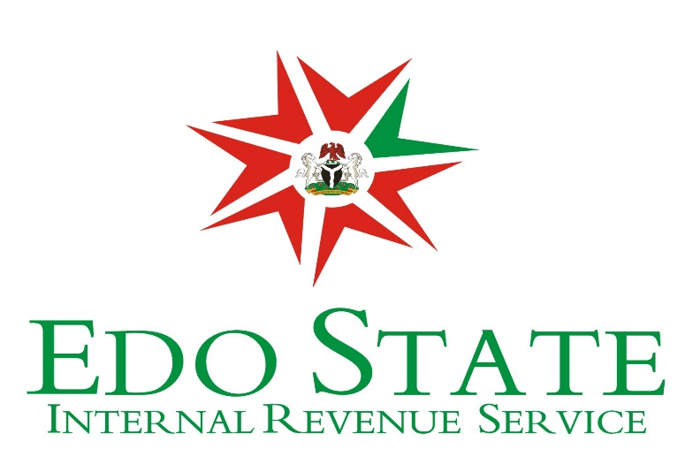

PROCESS OF ISSUANCE OF TAX CLEARANCE CERTIFICATE
- A Taxpayer pays fully the tax assessed by the tax authority on his income for the three years immediately preceding the current year of assessment. This takes about 3 to 5 minutes.

- Taxpayer sends an application letter, in writing, to the tax authority (in this case Edo State Internal Revenue Service, located at 80, New Lagos Road, New Benin, Benin City.) demanding for his tax clearance certificate stating reasons for the request. This may take up to 30 minutes, depending on the taxpayer.

- Taxpayer visits the Tax Office and he is given an interview sheet by the Tax Officer to complete. On completion, he/she is required to submit the completed form, together with his Tax Identification Number (TIN) and a current passport photograph to the Tax Officer. This takes about 30 minutes.

- For employees under Pay-As-You-Earn (PAYE), in addition to fulfilling items 1-3 above, the employee must submit a tax form H2 duly completed by the Accountant of his organisation/establishment and one month pay slip in each of the relevant years. This usually takes about 15 minutes. See https://eirs.gov.ng/files/paye_processes.pdf for more information.

- Once all the above requirements have been met, the tax authority issues the tax clearance certificate to the taxpayer within 2 weeks of demand as prescribed by the Law. However, Tax clearance certificate can be issued to the Taxpayer within 24hours upon meeting the above requirements.

NOTE:
1. The issuance of Tax Clearance Certificate is regulated by Section 85 of the Personal Income Tax Act Cap. P8 LFN 2004 (As amended). See PITA on https://eirs.gov.ng/files/Personal_Income_Tax_Act.pdf and https://eirs.gov.ng/files/Personal_Income_Tax_(Amendment)_Act.pdf

2. Tax Liability is computed in line with the returns from Taxpayers as prescribed by the Personal Income Tax Act 2004 (As amended). Fees/Rates are therefore not pre-determined.

For more information Visit: https://eirs.gov.ng/wp-content/uploads/2018/04/CONDITIONS-FOR-OBTAINING-TAX-CLEARANCE-CERTIFICATE.pdf

Signed by
The Chairman
EIRS

EIRS Official Contact
GSM: 0813 097 0146
Email: info@eirs.gov.ng

PROCESS OF OBTAINING TAX FORM H2
1. On request, the EIRS sends booklets of tax form H2 to PAYE remitting Establishments in the State. This takes about 24 hours to process the request.
2. The booklets are subsequently delivered to the establishments through the Tax Officer. This takes about 24 hours.
3. An employee who is demanding for his/her Tax Clearance Certificate (TCC) is required to visit the Accountant of his/her establishment to collect the Tax Form H2, which will be completed for him/her by the Accountant of the organization.
4. The completed form must be duly signed and stamped by the establishment before submitting same to the Tax Officer. This usually takes about 15 minutes.

NOTE:
1. The Tax Form H2 shows the total income an employee earned and the total tax paid in the last three (3).

