

**2022 Citizens’ Accountability Report**

Published: 25th Sept 2023

**Table of Contents**

Executive Summary 4

Section 1 Budget Outturn 5

Section 2 Revenue Outturn 8

Section 3 Expenditure Outturn 11

Section 4 Audit Findings 14

Section 5 Audited Financial Statements 16

Section 6 Top Sectoral Allocation 19

Section 7 Public Consultations with Citizens presenting the Annual Financial Statements 24

**About the Citizens Accountability Report**

|  |
| --- |
| *A Citizens’ Accountability Report (CAR) is a series of graphic and tabular illustrations of the contents of the Audited Financial Statements prepared by a government agency (State Audit office) on behalf of the government (Edo State) to the citizens to ensure accountability of public funds. This report details the government's performance in carrying out the duties assigned to it and the utilization of funds in the coffers of the government. This accountability report is based on the financial statements for the Financial Year (FY) 2022 and reports on State budget revenue and expenditure for 2022.*  ***Explanation of Key Terms used in this Report:***   * *Budget – unless otherwise stated, the budget refers to the Final Budget (i.e. the original budget, plus any adjustments that have been made via a supplementary budget / revised budget).* * *Actual – this is the actual amount of revenue collected or expenditure incurred over the course of the year.* * *Variance – for revenue items, this is calculated as Actual minus budget - a negative variance for revenues and inflows means actuals fell below budget, and vice versa for a positive variance. For expenditure, variance is calculated as budget minus actual - a negative variance for expenditures means actual expenditure was above budget, and vice versa.* * *Performance – this refers to the actual revenue / expenditure as a percentage of the budget. A performance of 100% means the full budgetary allocation was collected (revenue) or spent (expenditure). A performance of less than 100% means the full level of revenue collection or expenditure was not achieved. A performance of more than 100% means more revenue was collected than anticipated, or more money was spent than anticipated in the budget.* |

# Executive Summary

|  |
| --- |
| *The 2022 Budget of Edo State, with the theme “Budget of Renewal and Growth”, was passed on the 29th December 2021 and budget implementation commenced on 1st January 2023. The Budget for Fiscal Year 2022 reflects the Governor’s continual intent to Make Edo Great Again (MEGA) through promotion of social inclusion, economic empowerment for Edo citizens, through the deepening of investments in socio-economic, governance and security infrastructure; and through the implementation of initiatives that guarantee equal access to education, health care and social protection.*  *Some of the key goals and priorities of the 2022 budget includes; Human Capital Development through the transformation and enhancement of the Public Service, more investment in Basic Education and HealthCare; Urban / Regional Plans; Infrastructural development; Environmental Sustainability.*  *Aggregate revenue performance was 98.7% of the budgeted N222.57 billion in the final budget this is equivalent to N2.9 billion lower than the Budgeted – both Federation Account revenues and Internally generated revenue performed optimally. There was a very high performance from Federal Government Receipts and the State Internally generated Revenue which performed more than what was budgeted.*  *On the expenditure side, the actual total expenditure is about N207.12 billion (93.1%) this was N15.4 billion less than the budgeted amount of N222.57 billion. Capital Expenditure took the brunt of the expenditure shortfall, with performance of 88.0%. Much of the recurrent expenditure in 2022 was obligatory in nature so, based on the revenues; capital expenditure was largely focussed on completing on-going projects.*  *Government Reforms took a centre stage in the 2022 Fiscal Year as it enjoyed the highest proportion of total expenditure.*  *Some of the larger contracts were subject to delays due to weather and funding, and some amendments were made. Citizens projects were largely implemented as planned; albeit some minor carry over to 2022 as a result of funding short-falls.*  *The most material audit findings related to poor documentation and verification of source document.* |

# Budget Outturn

|  |
| --- |
| *This section outlines the performance of the main classifications of revenue and expenditure for the State.*  *The revenue performance (outturn) which shows the aggregate revenue performance is about 98.7%; thus Edo State received N219.63 billion in 2022. The critical causes of deviation include FAAC Revenues of N130.53 billion as against N101.97 billion, Budget financing actuals of N18 billion as against N23.9 billion; Internally Generated Revenue performed optimally at N45 billion as against N41 billion in the Revised Budget and Aids and Grant of N6.3bn actual against the budget. In general, Aggregate variance amounted to N2.9 billion.*  *On the expenditure side, the actual total expenditure is about N207.12 billion (6.9%) less than the budgeted amount which was N222.57 billion. Out of the total Capital expenditure budget of N101.17 billion, the actual capital expenditure was N89.05 billion. This indicates that capital expenditure performed at 88.0% but for the late release of funds resulted in the shortfall of revenue required for maximum execution of the capital budget, hence this level of performance.*  *Observe that personnel expenditure (employees’ salaries and wages) has fared better in term of outturn. This is due to a more realistic projection as well as the state government policy on reduction of payroll frauds. Conversely, the performance of other recurrent expenditure which include overhead cost, grants, subsidies & subvention to parastatals was within threshold also.* |

Table 1 Budget Outturn



* Variance and Performance is assessed against final budget. Negative Variance for Revenues items means revenue actuals were below budget. Negative variance for expenditure items means actuals were above budget.

Figure 1 Budget Outturn Graphs

|  |  |
| --- | --- |
|  |  |

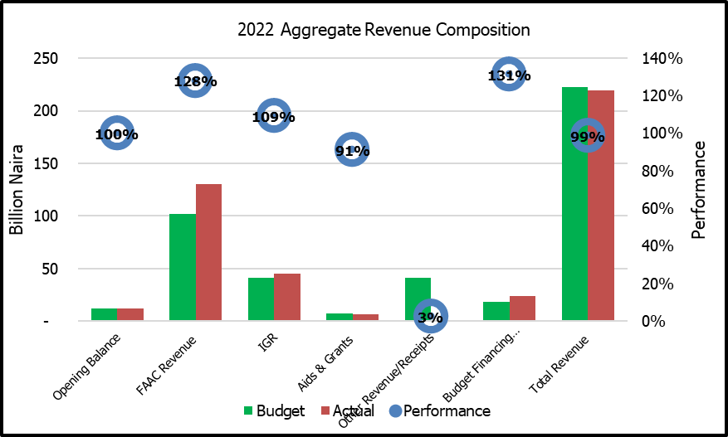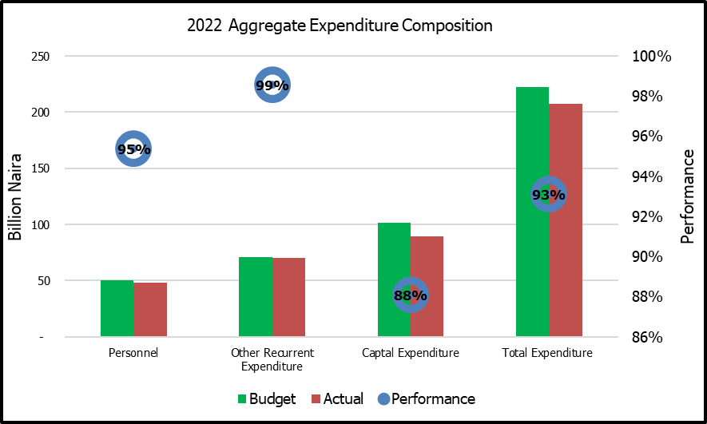

# Revenue Outturn

|  |
| --- |
| *This section outlines the approved and actual revenue generated internally by the State and disaggregated by sources. The section also outlines the revenue information from 10 performing revenue agencies in the State.*  *Table 2 below shows the approved and actual revenue generated internally by the State and disaggregated by sources while Table 3 outlines the revenue information from 10 performing revenue agencies in the State.*  *The state government has continued to spur the fiscal space in a manner that would enhance IGR growth. Consequently, various IGR drive initiatives have been implemented by the State. These efforts are expected to buffer revenue available for the execution of the annual and effective delivery of services to the citizens of the state.*  *The total IGR performance in the last completed fiscal year was 109%. The IGR has two broad categories, namely the Tax Revenue and Non-tax Revenue. The outturn for the tax and non-tax revenue was 99.0% and 134.1% respectively.*  *The critical source of Tax Revenue for Edo state include personal taxes which recorded 95.6% performance during the period under review. A key component of the personal taxes is the PAYE which recorded the highest value. (107.8%) because it is generally deducted at source. As indicated in the Table 2 below, except for Capital Gains tax, licences general, rent on land and others general, fess general and rent on Government buildings, the actual realized fall short of the budgeted amount for all other revenue sources.*  *The State Internal Revenue Service (EIRS) which is the highest revenue generating institution of the state had a budget of N31.6 billion but realised a total of N30.7 billion, equivalent to 97.1% Performance. Strengthening the EIRS remains pivotal to the needed upscale in the revenue generation agenda of the state. Following the EIRS are the Ministry of Education that realised 6.9 billion as against N0.9 billion initially budgeted, Edo Geographical Information Service (Edo GIS) realised N1.5 billion while Ministry of Finance realised N1.3billon.*  *The MDAs with the highest level of outturn include the Ministry of Finance 3136%, Ministry of Education 761%, and Ministry of Ministry of Transport 709.8%*  *This information is presented in Table 3 below.* |

Table 2 Revenue Outturn by Item



* Variance and Performance is assessed against final budget. Negative Variance for Revenues items means revenue actuals were below budget.

Table 3 Revenue Outturn by MDA



* Variance and Performance is assessed against final budget. Negative Variance for Revenues items means revenue actuals were below budget.

# Expenditure Outturn

|  |
| --- |
| *Table 4 below looks at the expenditure outturn, how much expenditure was allocated to each main classification, and how much was actually spent.*  *Broadly, Capital Expenditure got N101.17 billion 45% of the total budget size of N222.57 billion while recurrent expenditure was allocated N121.4 billion, equivalent to 55% of the total budget size. The share of actual capital expenditure in the total expenditure of N207.12 billion was N89.14 billion representing 43%of total actual expenditure, while actual recurrent spending was allotted the remaining N118.07 billion which is (57%) approximately.*  *However, in terms of aggregate expenditure outturn, recurrent expenditure received about 2.7% less than its final budget size while the capital expenditure outturn was 88.0%, implying about 12% deviation or N12.11 billion less than the final capital budget size.*  *The breakdown of actual recurrent expenditure shows that Salaries and wages accounted for 15.7% (N32.62 billion) while social contributions received 1.1% (N2.3 billion), Social Benefits, Overheads and Public debt charges accounted for 6.4% (13.17 billions), 16.2% (N33.58 billion) and 17.6% (N36.4 billion) respectively.*  *Clearly, with the exception of salaries, wages and allowances and Social Contribution which recorded 96.5% and 67.7% performance, all components of recurrent expenditure performed significantly. The most significant is Social Benefits which includes Pensions and Gratuities, State Insurance Contributions followed by the Public Debt Charges..* |

Table 4 Expenditure Outturn



Variance and Performance is assessed against final budget. Negative Variance for Revenues items means revenue actuals were below budget.

Figure 2 Expenditure Composition

|  |  |
| --- | --- |
|  |  |

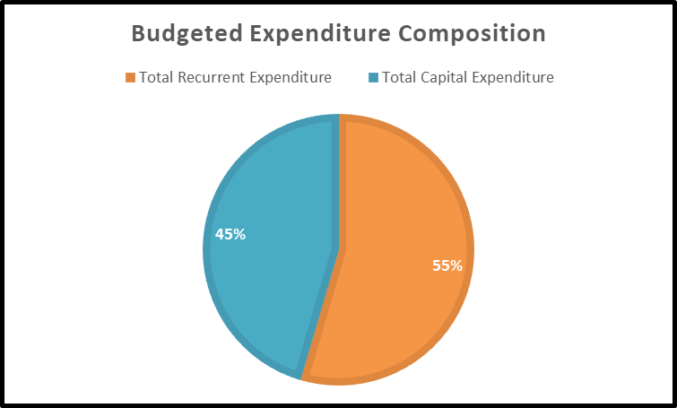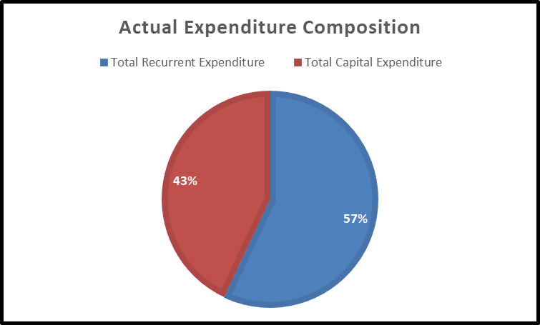

# Audit Findings

|  |
| --- |
| *This section outlines the findings from the Audit process on fiscal year budget implementation, including queries, unremitted funds, government property sales, etc. The Auditor General’s Statement should include revenue and expenditure, audited financial statement, finding from the audit as contained in the audited financial statement.* |

|  |
| --- |
| **A: RECURRENT EXPENDITURE PAYMENT VOUCHERS**  The queried recurrent expenditure payment vouchers of Ministries, Departments and Agencies (MDAs) were without proper documentations such as receipt/invoices, store receipt voucher (SRV), minutes of approval etc |
| **B: CAPITAL EXPENDITURE PAYMENT VOUCHERS**  The queried capital expenditure payment vouchers of Ministries, Departments and Agencies (MDAs) were without invoice, Exco approval, Audit Certificate, delivery notes, engineering certificate etc |
| **C: SUMMARY OF QUERIED PAYMENT VOUCHERS**  Thirty-two (32) queries totaling **N10,870,548,283.10** (ten billion, eight hundred and seventy million, five hundred and forty-eight thousand, two hundred- and eighty-three-naira, ten kobo) as presented in table 5 |
| **D: ASSETS (PROPERTY, PLANT AND EQUIPMENT) REGISTER**  The legacy Assets of the State have been valued by a consultant. Assets register is maintained for additional assets acquired |
| **E: BILLS PAYABLE**  Total bills payable for the period is **N28,503,347,938.82** (twenty-eight billion, five hundred and three million, three hundred and forty-seven thousand, nine hundred- and thirty-eight-naira, eighty-two kobo |
| **F: INVESTMENTS**  The State has shares in thirty-eight (38) companies – thirty-two (32) quoted while six (6) unquoted |
| **G: AIDS AND GRANTS**  The sum of **N6,383,184,911.08** (six billion, three hundred and eighty-three million, one hundred and eighty-four thousand, nine hundred and eleven naira, eight kobo was received as Aids and Grants in the year 2022 as follows: Domestic Grants – **N5,953,684,911.08** and Foreign grants **N429,500,000.00** |
| **H: CONTINGENT LIABILITIES ON BANK GUARANTEES AND**  There were no bank guarantees outstanding during the fiscal year 2022 |
| **I: PERFORMANCE GUARANTEES**  No findings |
| **I: ADHERENCE TO PROCUREMENT PROCEDURES**  All procurement procedures were duly observed during the fiscal year 2022. |

Table 5 Top Ten Audit Queries



# Audited Financial Statements

|  |
| --- |
| *This section outlines a breakdown on the state's audited public expenditure and revenue for the fiscal year in review. The expenditure budget figures, consolidated revenue fund and audited cash flow statement based on the audited financial statement are represented here for citizens' understanding.*  *The tables provide a more detailed breakdown of revenues and expenditures in 2022. Some of the highlights (major variances) are as follows:*   * *From the revenue point, 13% derivation, Statutory Allocation, other Federation Account Distributions, Independent Non-Tax Revenue and Domestic Loans performed more than budgeted.* * *From the Expenditure point, there was an increase in actual Capital Expenditure between 2021 and 2022 which shows the State Government commitment to provision of social amenities.* * *The State also performed optimally in its Independent Non-Tax Revenues to demonstrate the State’s commitment to improvement in IGR.* |

Table 6 Statement of Income and Expenditure



Variance and Performance is assessed against final budget. Negative Variance for Revenues items means revenue actuals were below budget.

Table 7 Statement of Changes in Net Assets



# Top Sectoral Allocation

|  |
| --- |
| *Tables 8, 9 and 10 outline the financial information on top Sector allocation and the actual expenditure from the implementation of the fiscal year budget.*  ***Recurrent Expenditure -*** *Presented in Table 8 is data on recurrent expenditure of top 10 Sectors of the State. It was observed that for all the sectors listed except Office of Governor, Office of the Accountant General, Office of the Secretary to the State Government and the State House of Assembly, actual expenditures were more than budget. The level of performance is 112.0% across all the MDAs/sectors. Office of the Governor and the Ministry of Education got the highest share of approximately 23% each.*  ***Capital Expenditure*** *– Table 9 presents capital expenditure of top MDAs/sectors. The sectoral capital expenditure performance shows that 5 of the top allocated MDAs performed more than 100% while the remaining 5 performed below. As indicated in the table 9, infrastructure got the highest actual expenditure which is about N22.2 billion or 28.1% of the total capital expenditure (N79 billion). Physical Planning and Urban Development received N9.7 billion, equivalent to 12.3%. However, Physical Planning and urban Development recorded the highest performance.*  ***Total Expenditure*** *– As indicated in Table 10 for the top highest spending MDAs/sectors, Infrastructure received the highest total actual expenditure which is about N 22.9 billion (20.7%) of the total actual expenditure N179.8 billion, followed by Directorate of Government House and protocol which got N15.1 billion (8.4%).* |

Table 8 Top Ten Recurrent Expenditure Sectors / MDAs



Table 9 Top Ten Capital Expenditure Sectors / MDAs



*Variance and Performance is assessed against final budget. Negative Variance for Revenues items means revenue actuals were below budget.

Table 9 Top Ten Total Expenditure Sectors / MDAs



*Variance and Performance is assessed against final budget. Negative Variance for Revenues items means revenue actuals were below budget.

Figure 3 Top Ten Capital Expenditure Sectors Graph

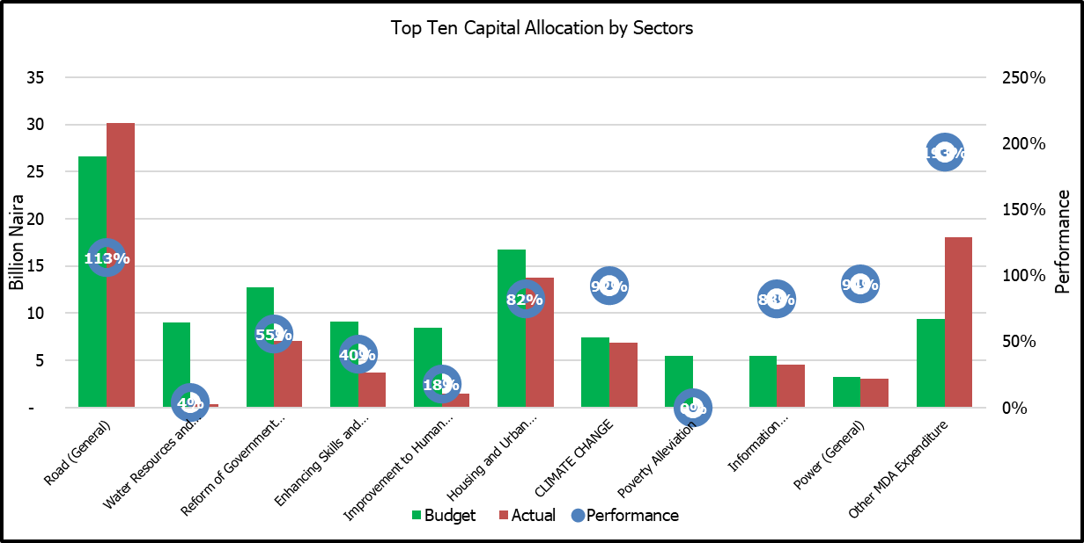

Figure 4 Top Ten Total Expenditure Sectors Graph

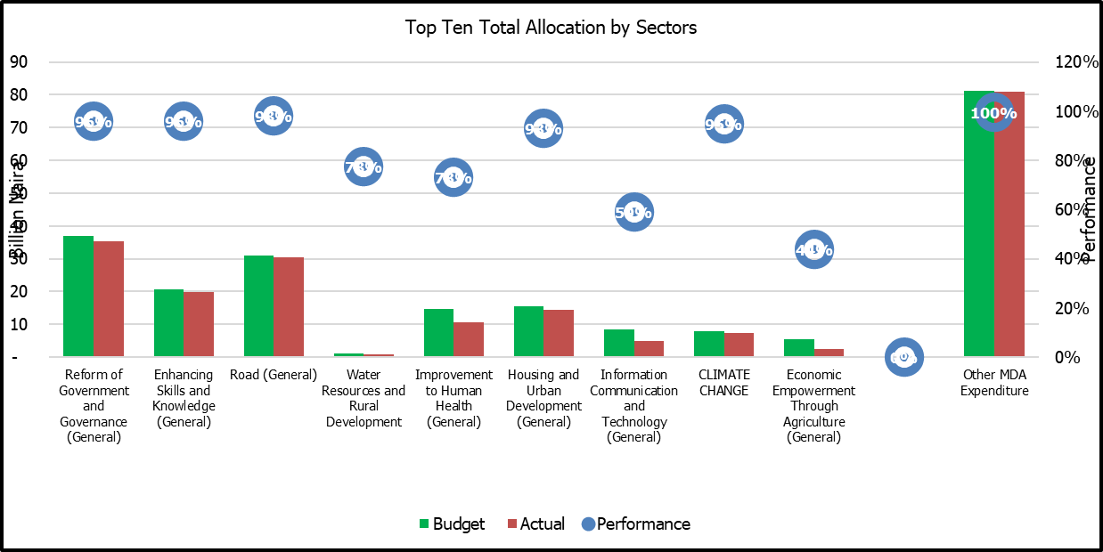

# Public Consultations with Citizens presenting the Annual Financial Statements

|  |
| --- |
| *The FY 2022 Audited Annual Financial Statements for Edo State can be found on the State Government Website, at the following specific address:* [*www.edostate.gov.ng/financials*](http://www.edostate.gov.ng/financials)  *Edo State Government published the Audited Annual Financial Statements on the12 th July 2022. Subsequently, one town hall consultations was held on Monday 25th September, 2023 to present the Financial Statements.*  *Citizens comments were minute and minutes of the meetings are also available at the above web address.* |