ict.edojudiciary@gmail.com
EDO STATE
JUDICIARY
SMALL CLAIMS COURT
HIGH COURT OF JUSTICE
BENIN CITY

EDO STATE SMALL CLAIMS COURT SERVICE DELIVERY TIMELINES
SERVICE/TASK | CONDITIONS/REQUIREMENTS | TIMELINES | FEES/REMARKS
Filing with increased transparency of official fees and procedures | - An individual who is 18years and above  - Claim to be filed at the Small Claims Registry  - Claim filed must not exceed N5,000,000 (five million naira)  - An individual less than 18years of unsound mind can file through the Guardian  - Partnership, Association and Corporation can file | Within 24 hours | Published on State official website: fees, procedures and service delivery.  Claim:  - N10,000 and below -N450  - N10,001-N20,000 -N750  - N20,001-N50,000 – N1,125  - N50,001-N100,000 –N1,500  - N100,001-N600,000 –N3000  - N600,001-N1,000,000 –N3,750  - N1,000,000-N5,000,000 – N7,500
Forms | - Forms SCA1-SCA8 are available to parties as required at the court registry |  | Free
Service of Court Process | - Court Bailiff serves all Small Claims Courts processes | 48 hours | - The party who files, pays for service.  - Service within the state is N200 per kilo  - Service outside the state N500 and above per kilo
Trial | - Trial commences at the Small Claims Court by a Magistrate  - Witnesses (if any) can be called to give evidence  - Judgment is delivered at the end of trial | Within 60 days or 2 months | - Free  - If represented by a lawyer, a fee will be charged by the lawyer  - Free
Enforcement of Judgment | A bailiff of the Small Claims Court will enforce the Judgment | After 30 days of Judgement | The Small Claims Registry will determine the fee to be paid at the Registry
Appeals | Notice of appeal must be filed within 14days of the Courts Judgement | 14 days | A fee is paid for Notice of appeal

Mrs F. I. Oghoator
Chief Magistrate Special Grade
franca4henry@yahoo.com
08023589621

Mr. G. L. Wilson Esq.
Chief Magistrate Grade 1
wilsonlawrence266@gmail.com

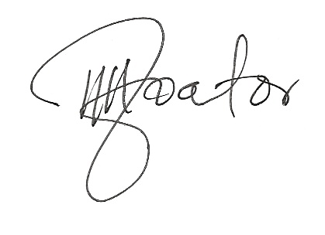

________________
F.I. Oghoator
Coordinator Edo State Small Claims Court

