
Date of Publication
28/10/2024

Edo State Government
2024 QUARTER THREE Budget Performance Report

Contents
1 Summary of Performance 2
1.A Introduction 2
1.B Revenue Performance 3
1.C Recurrent Expenditure Performance 3
1.D Capital Expenditure Performance 3
1.E Conclusions 3
2 Budget Reports 5
2.A Summary 5
2.B Revenue by Administrative Classification 6
2.C Revenue by Economic Classification 8
2.D Expenditure by Administrative Classification 11
2.E Expenditure by Economic Classification 27
2.F Expenditure by Function 33

List of Reports
Table 1: Budget Summary 5
Table 2: Total Revenue by Administrative Classification 6
Table 3: Total Revenue by Economic Classification 8
Table 4: Total Expenditure by Administrative Classification 11
Table 5: Personnel Expenditure by Administrative Classification 16
Table 6: Overhead Expenditure by Administrative Classification 19
Table 7: Capital Expenditure by Administrative Classification 23
Table 8: Other Expenditure by Administrative Classification 26
Table 9: Total Expenditure by Economic Classification 28
Table 10: Total Expenditure by Function 34
Table 11: Personnel Expenditure by Function 37
Table 12: Overhead Expenditure by Function 39
Table 13: Capital Expenditure by Function 41
Table 14: Other Expenditure by Function 43
Table 15: Total Expenditure by Programme 44
Table 16: Capital Expenditure by Programme 45

Summary of Performance

Introduction
This Budget Performance Report for EDO State is prepared quarterly and issued within 4 weeks from the end of each quarter.
This report includes the original approved appropriation for the year 2024, the revised appropriation which was against each organizational unit for each of the core economic classifications of expenditures (Personnel, Overheads, Capital, and Others); the actual expenditures for the quarters Q3, attributed to each organizational unit, as well as the cumulative expenditures for the year to date, and balances against each of the revenue and expenditure revised appropriations.
This quarter three report is assessed against the 2024 Revised budget.
The core economic classifications refer to:
- Personnel – Economic Sub-Account Type 21
- Overheads - Economic Account Class 2202
- Capital - Economic Sub-Account Type 32
- Others - Economic Account Classes 2203-2209 as applicable
This Budget Performance Report is produced by the Office of the Accountant General in collaboration with the Ministry of Budget and Economic Planning. It is published on the Edo State website. www.edostate.gov.ng/financials .
Edo State 2024 Original Budget of N342.82 billion christened “Budget of finishing strong” was signed into law on Friday 29th December 2023. Upon certain economic realities, the Budget was revised to N 407.38 billion in the second quarter and N 450.384 billion in the third quarter of 2024.
The Budget had an Initial Opening Balance budget of N10.00 billion which was revised to N14.23 billion in the second quarter. Statutory Allocation budget of N55.59 billion was reviewed downward to N24.20 billion in the second quarter and was reviewed upward to N29.20 billion in the third quarter, initial Value Added Tax (VAT) budget of 38.93 billion was increased to N60.84 billion and further increased to 70.81 billion in the third quarter revision, other FAAC Receipts which comprises electronic money transfer exchange rate gains and other forms of Revenues from the Federation Account budget was increased from 90.83 billion to 158.68 billion in the second quarter and was further increased to N200.70 billion. In total FAAC receipts budget stood at 300.72 billion.
The Internally Generated Revenue (IGR) budget at the beginning of the year was N71.69 but during the budget review period was increased to N75.69 billion in the second quarter budget revision. Aids and Grants, Internal and External Loans remained unchanged at N10.00 billion, 5.00 billion and 16.45 billion respectively, while the Capital Development Receipts budget was reviewed downward from 44.34 billion to 41.79 billion in the second quarter and reviewed further downwards to N31.29 billion in the third quarter budget revision exercise.
On the expenditure side, as a result of the increase in Minimum wage in Edo State to 70,000.00, Personnel Cost budget was reviewed upward from N48.32 billion to 58.38 billion and further increased to 58.60 billion in the third quarter, Overhead Cost budget which was initially N50.35 billion was reviewed upward to N63.24 billion and further increased due to the inflationary pressures in the country to N71.42 billion in the third quarter. Capital expenditure budget which initially stood at N 188.55 billion was increased to N195.96 billion in the second quarter and further increased to 258.04 billion in the third quarter. Pensions and Gratuities budget was reviewed upwards from N16.65 billion to N17.65 billion and further increased to 19.65 billion. Public debt charges budget remained unchanged at N42.50 billion.

Revenue Performance
The Edo State Government share of FAAC as at 30th September, 2024 was N247.74 billion, showing an average quarterly performance of 110%, this represents 82.4% of the full year revised budget estimate of N300.72 billion. It shows that FAAC Receipts are performing above expected receipts on a quarter-by-quarter basis. A critical analysis shows that as at Q3, statutory allocation performed at 50%, while VAT stood at 94% and other FAAC revenues amounted to 124%.
Independent Generated Revenue (IGR) as at 30th September 2024, performed at 93% (N52.68 billion), this represents 69.6% of the Budgeted receipts. It should on note that Q3 has the highest performance of 94% as against Q2 and Q1 performance which was constant at 91%. This is a good fit as the State’s Revenue has shown efficiency in revenue generation
Other Receipts which include Loans, grants and other capital receipts amounted to N17.97 billion representing 30.1% of the full year expected receipts. This we expect to increase in the last quarter as we have met most of the criteria expected of the State.

Recurrent Expenditure Performance
The total recurrent expenditure (including personnel and overhead cost) as at 30th September, 2024 was N127.28 billion (88% performance), which is 66.2% of the total revised recurrent expenditure of N192.35 billion in the approved 2024 Revised budget. Of this amount 29% is attributable to Personnel cost and other personnel emoluments while the remaining 71% is attributable to overheads and other recurrent expenditures. It should be noted that total recurrent expenditure has maintained an average expenditure rate of 88% on a quarterly basis.
A closer look into Personnel Cost which includes salaries, pensions and gratuity payments for Q3 amounted to N51.50 billion, which has an average performance of 85%, This amount represents 66.7% of the total Personnel Budget of N58.60 billion.
Q3 Overhead expenditure was N75.73 billion which is 66.5% of the approved revised budget. Quarterly performance on average stood at 90%

Capital Expenditure Performance
Total actual Capital Expenditure as of 30th September 2024 was N176.02 billion which is 68.02% of N258.04 billion (total Revised Capital Expenditure) for Fiscal Year 2024. Quarter-to quarter performance shows an average of 91%. A critical look at the sectoral performance of Capital Expenditure should that the Economic Sector took a major share of 73% of the total amount spent on Capital projects so far and this is as a result of Government’s resolve to complete all existing projects.

Conclusions
It should be noted here, a look at the ratio of capital expenditure to the total expenditure of N303.30 billion as at 30th September, 2024 stood at 58%. This is unprecedented in the administration as the present administration of Godwin Obaseki prioritises projects delivery and this is as a result of his focus on critical infrastructure.
With the improvement in Revenues both from Federal Sources and Internally Generated Revenue, the State Government is keen on improving Infrastructure especially as it is in the process of finishing strong. She has been consistent in the monthly payment of workers’ salaries, including pensions and gratuities to retirees as one of its topmost priorities. It should also be of note that the State is the first state in Nigeria to increase the Minimum wage of workers to 70,000.00
Even with the rains, the state government is focus on finishing all projects initiated which include the construction of the Stella Obasanjo Hospital (outward patient department and in-patient department, state of the art mortuary, supply of medical equipment and other infrastructures), the school of health technology. The Government is creating hubs around the state (education hub, agricultural hub, technology hub). The civil service has gone fully digital. There is also the provision of fibre optics cable across the 18 Local Government Areas of the State, this is with the intention of connecting All Local Government Council Secretariats, Primary health care centres, all education facilities (primary and secondary schools and tertiary institution) across the state, the provision of free Wi-Fi connectivity for the citizenry, these are all part of his policy to make Edo State the 1st smart state in sub-sahara.
Though with these landmark projects on-going, there are still lots to be covered especially as the rains have hampered many of the road projects. It is anticipated that the Government would meet her full budget implementation across the State even as it hands over to a new administration in the 4th quarter.

Budget Reports

Summary
Table 1: Budget Summary
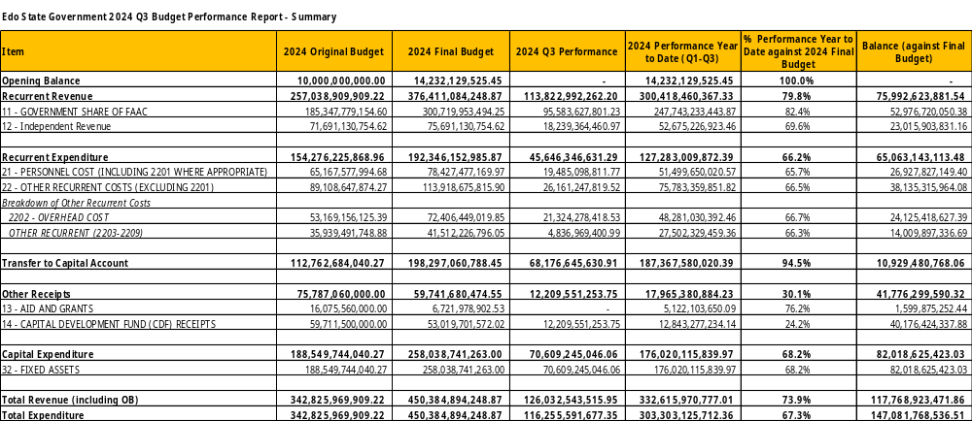

Revenue by Administrative Classification
Table 2: Total Revenue by Administrative Classification
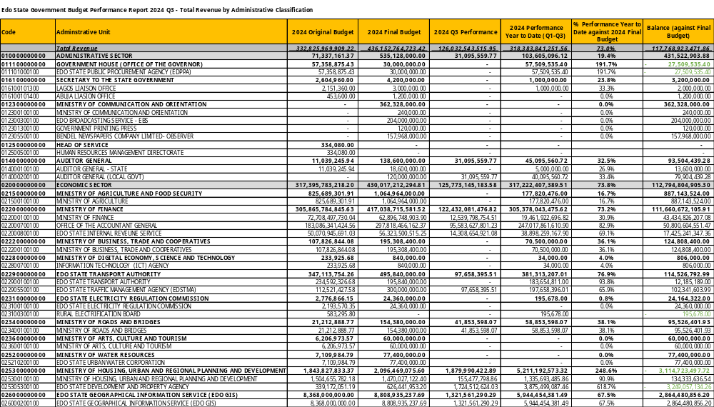
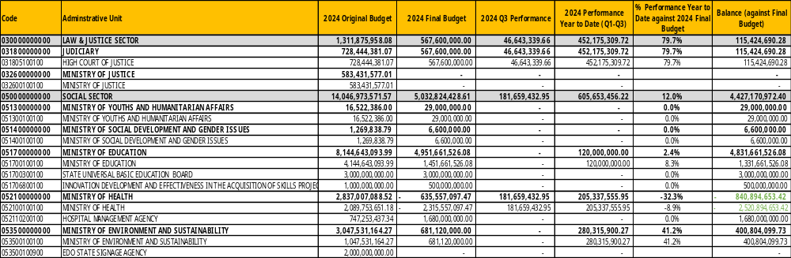

Revenue by Economic Classification
Table 3: Total Revenue by Economic Classification
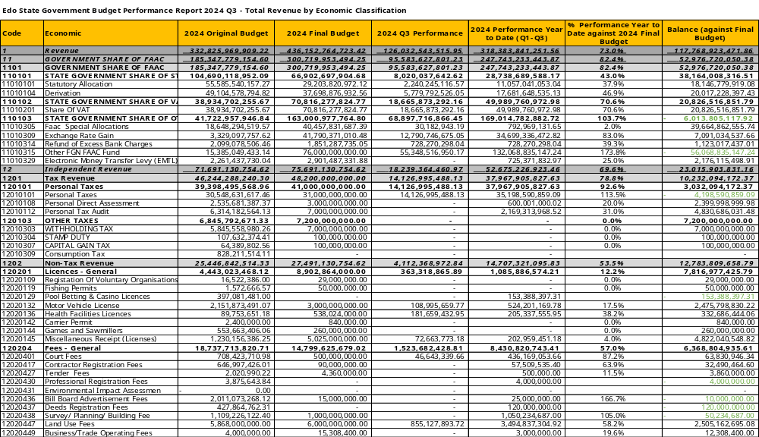
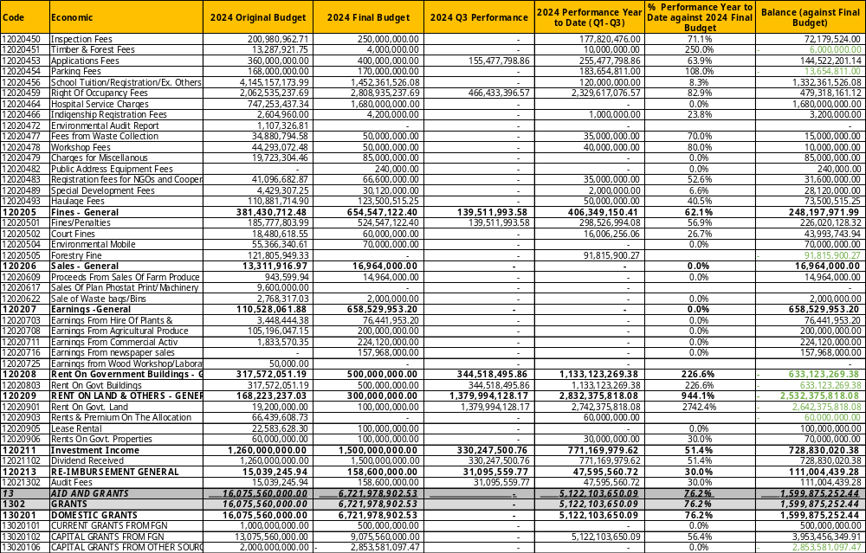
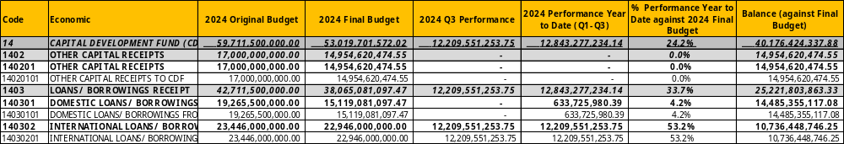

Expenditure by Administrative Classification
Table 4: Total Expenditure by Administrative Classification
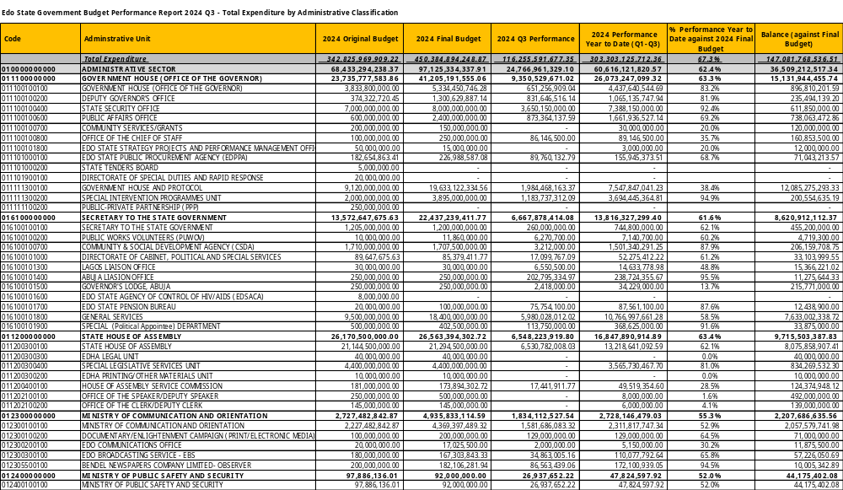
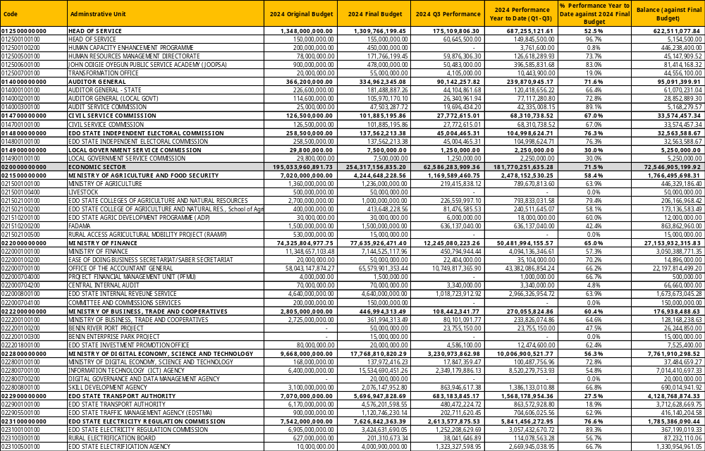
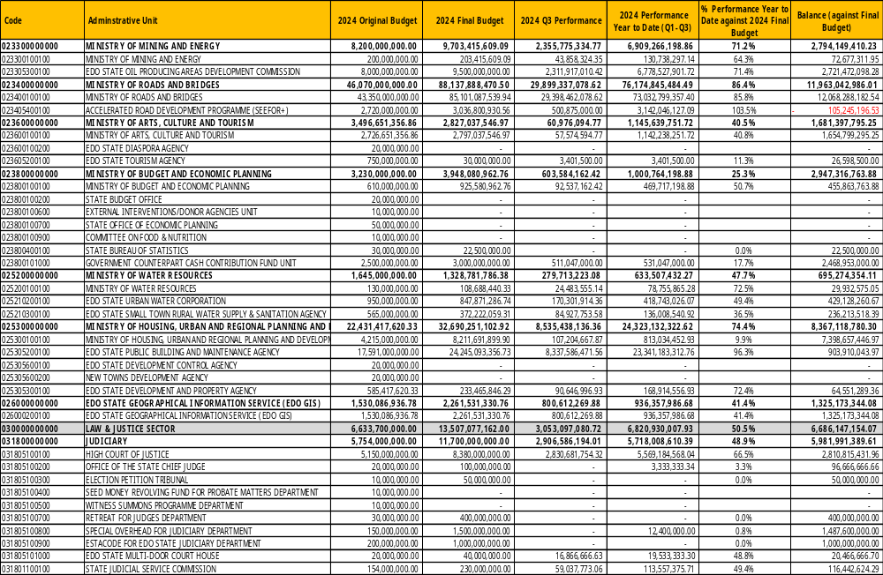
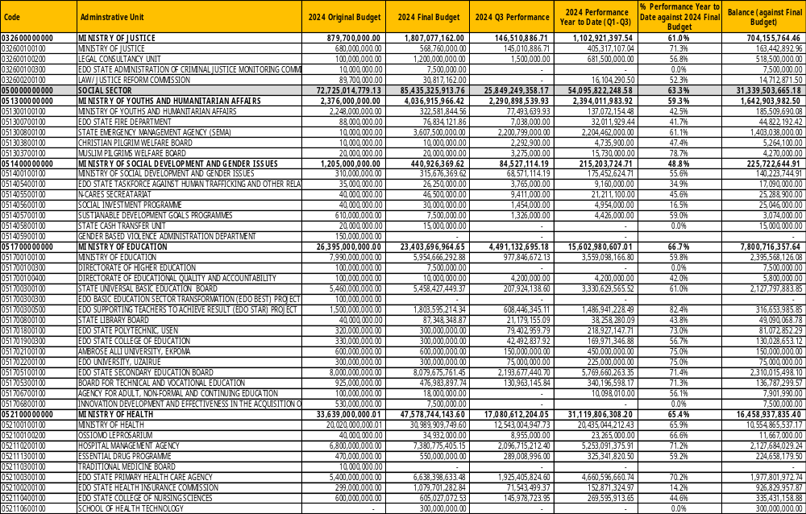
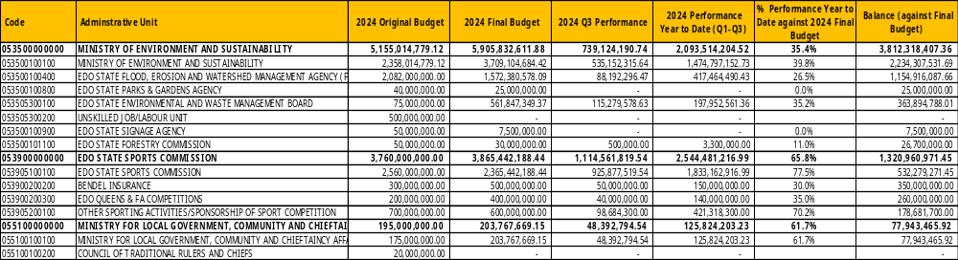
Table 5: Personnel Expenditure by Administrative Classification
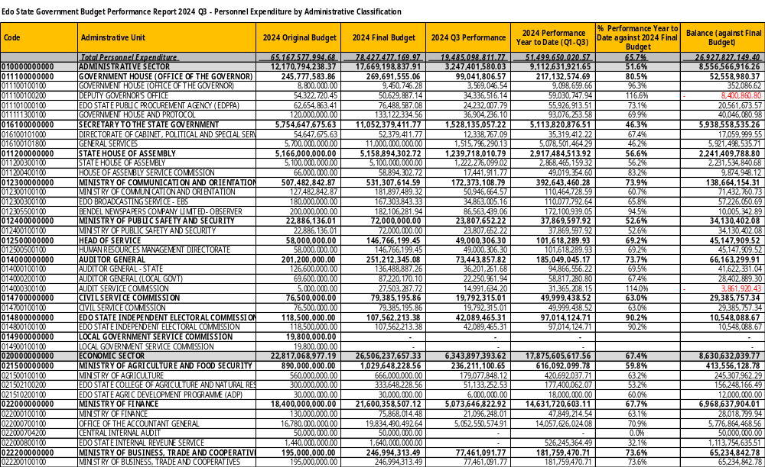
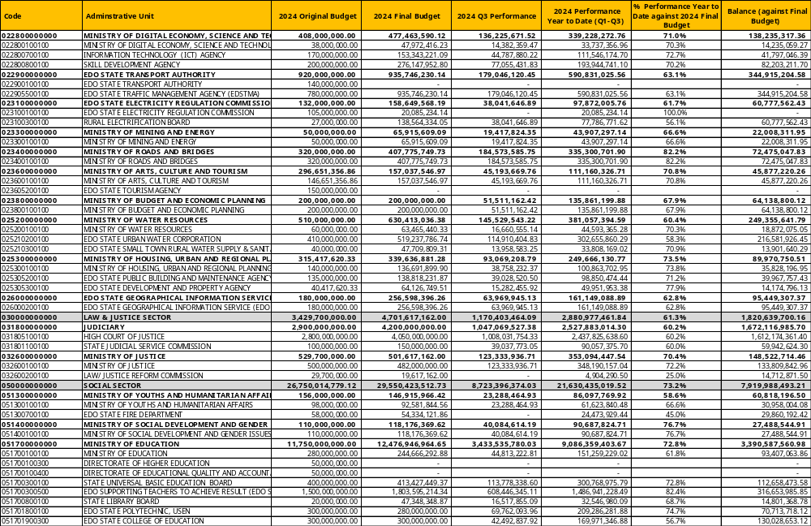
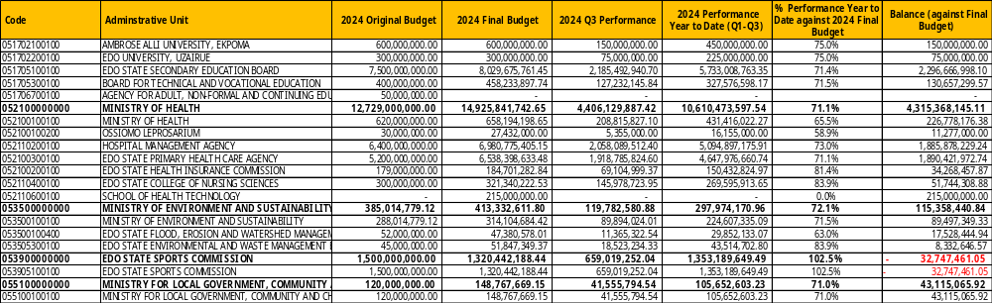
Table 6: Overhead Expenditure by Administrative Classification
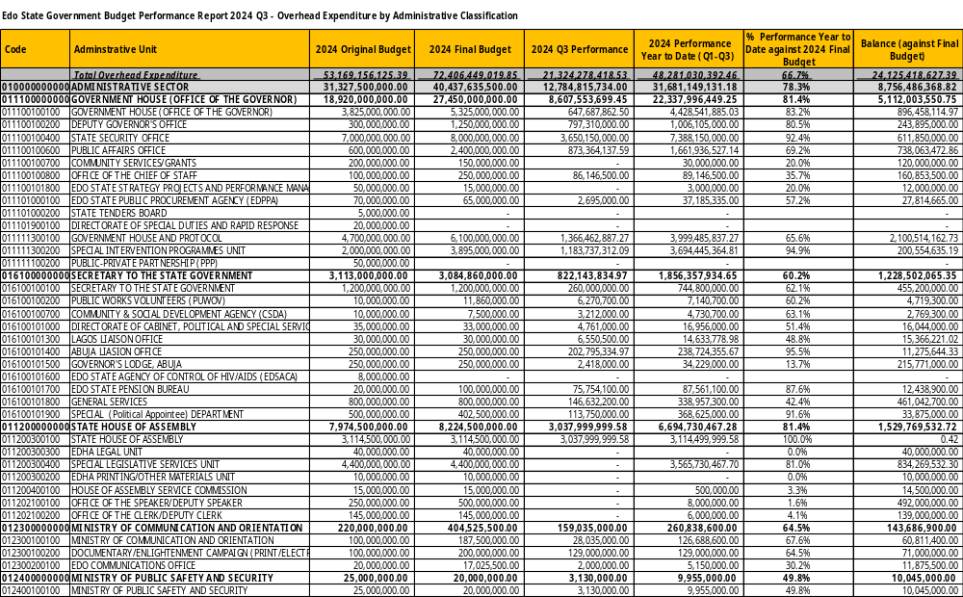
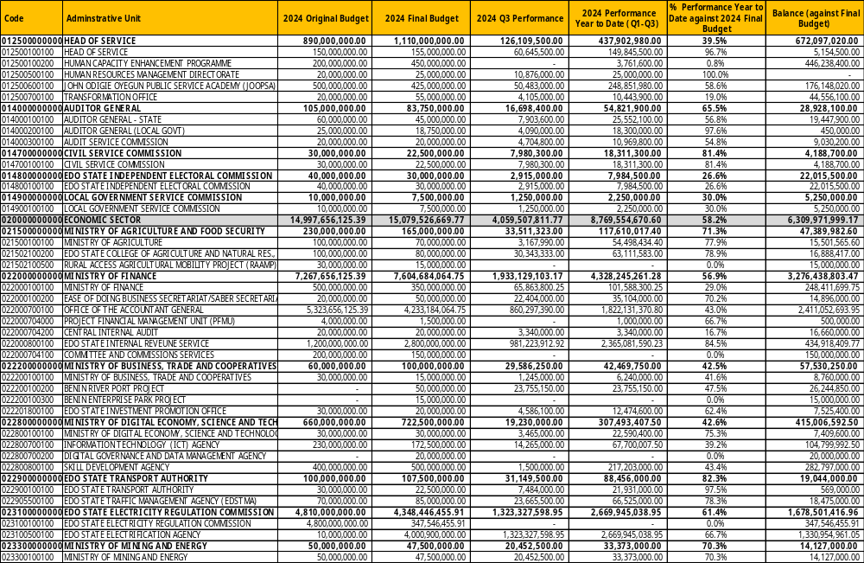
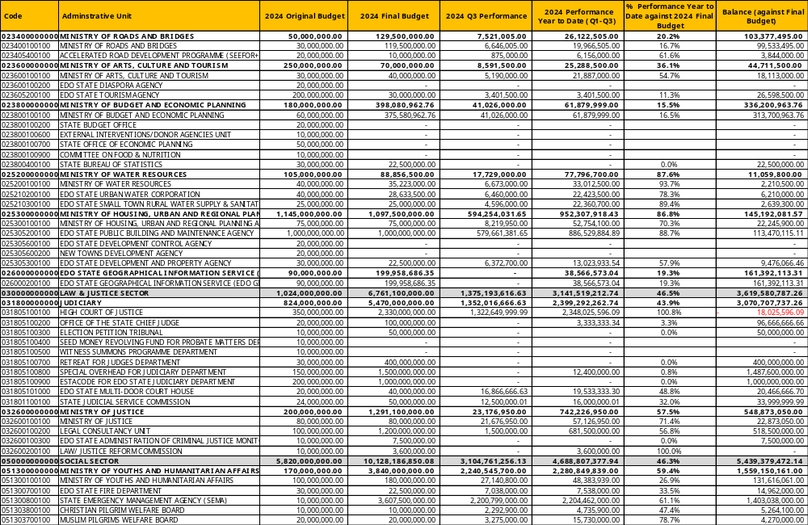
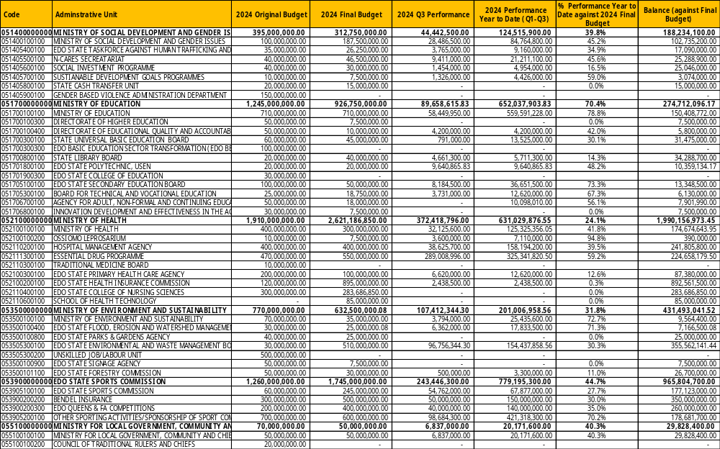
Table 7: Capital Expenditure by Administrative Classification
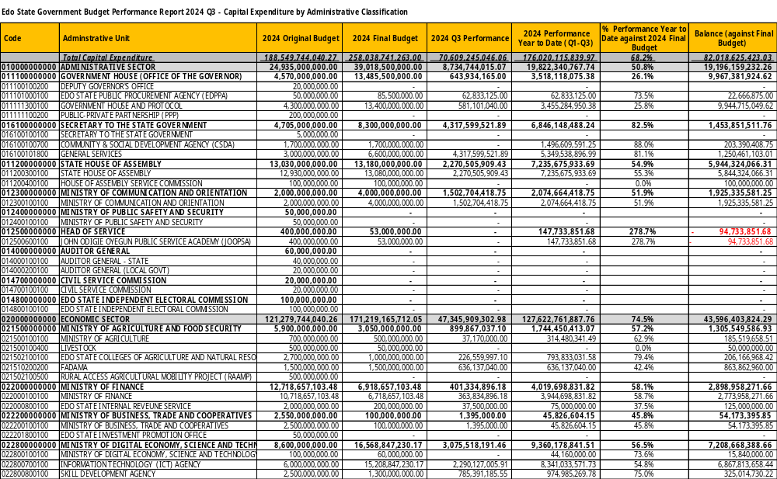
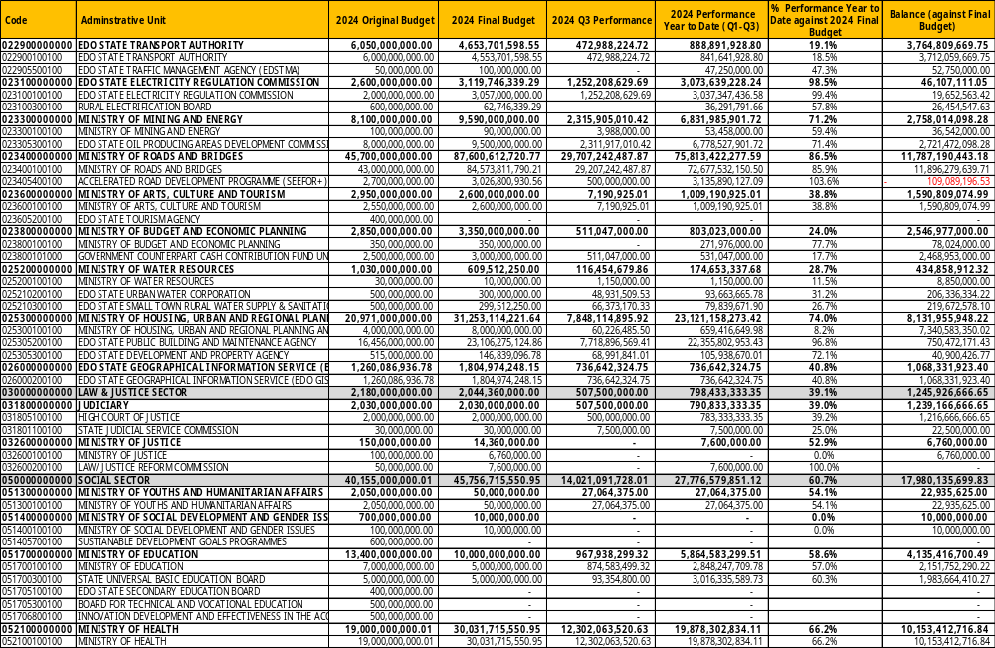
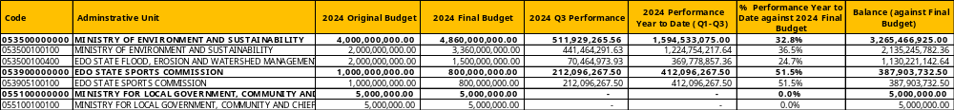

Table 8: Other Expenditure by Administrative Classification
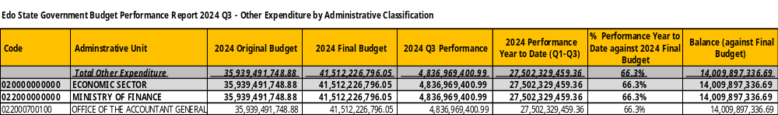

Expenditure by Economic Classification
Table 9: Total Expenditure by Economic Classification
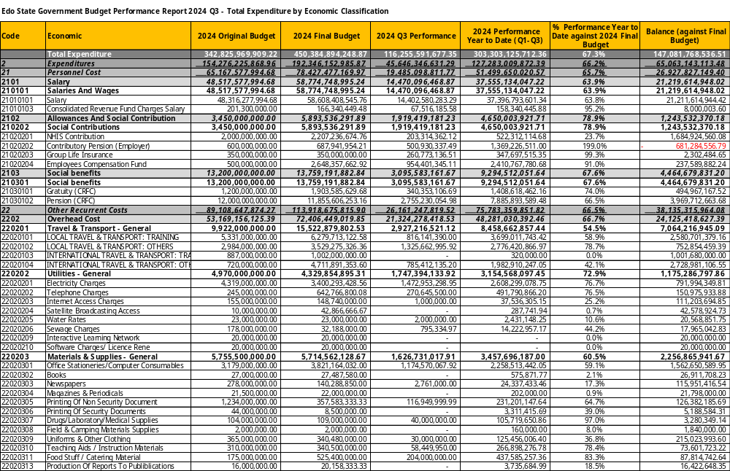
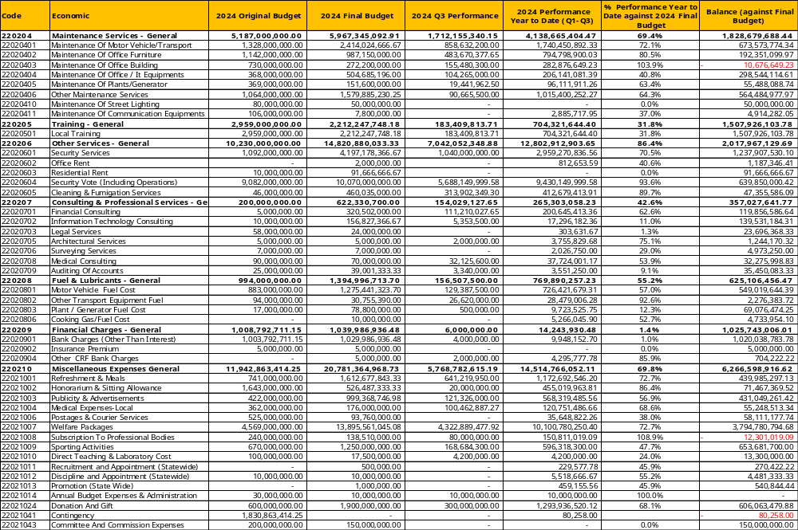
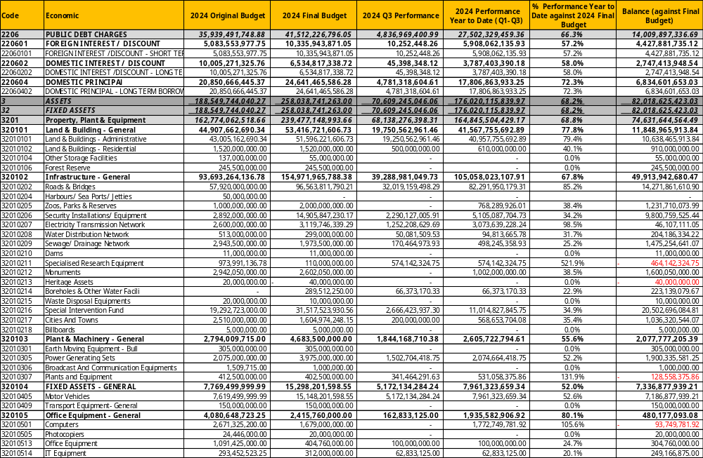
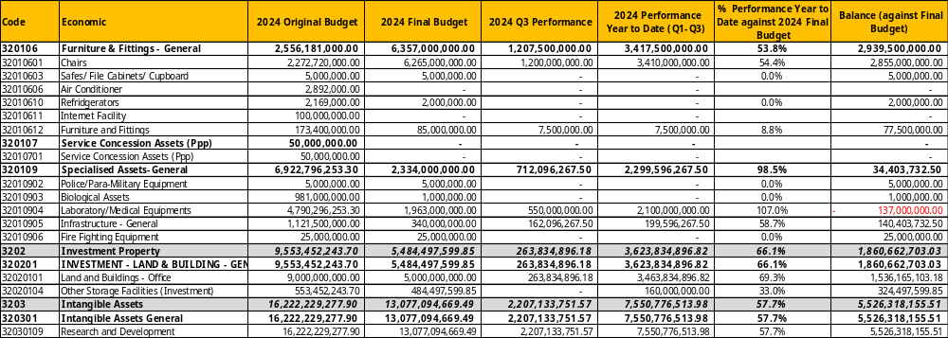

Expenditure by Function
Table 10: Total Expenditure by Function
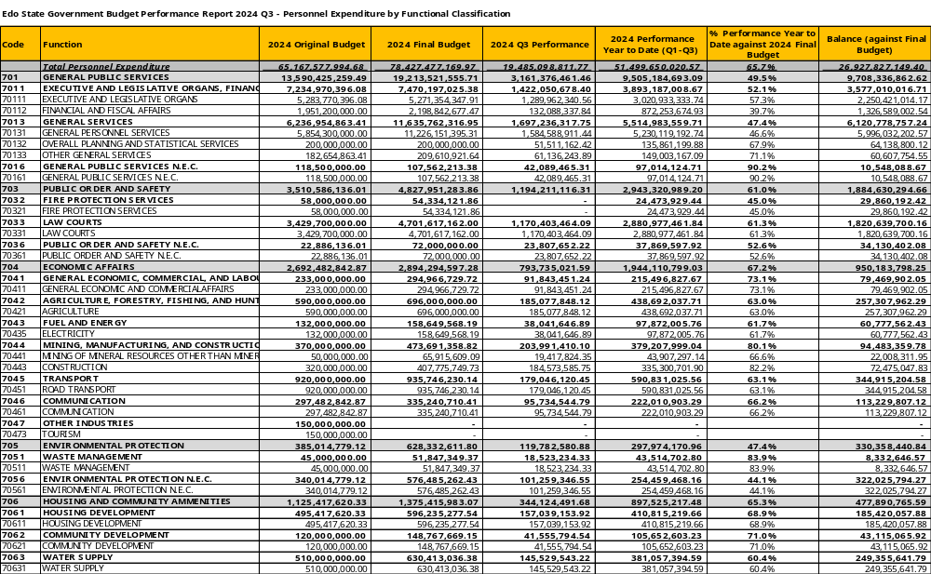
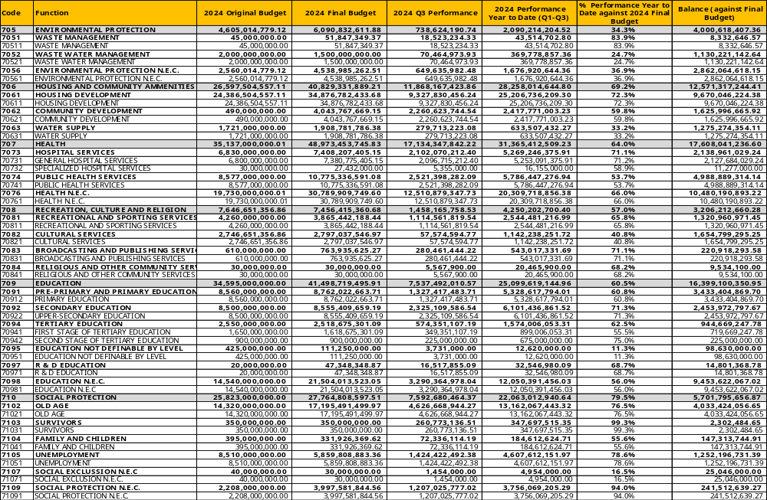
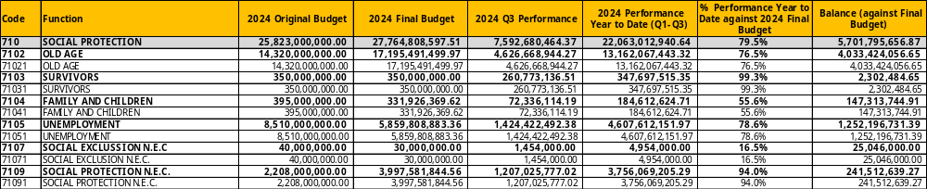
Table 11: Personnel Expenditure by Function
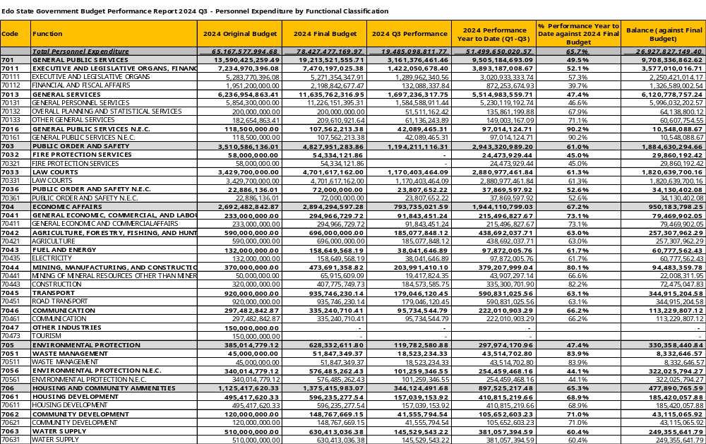
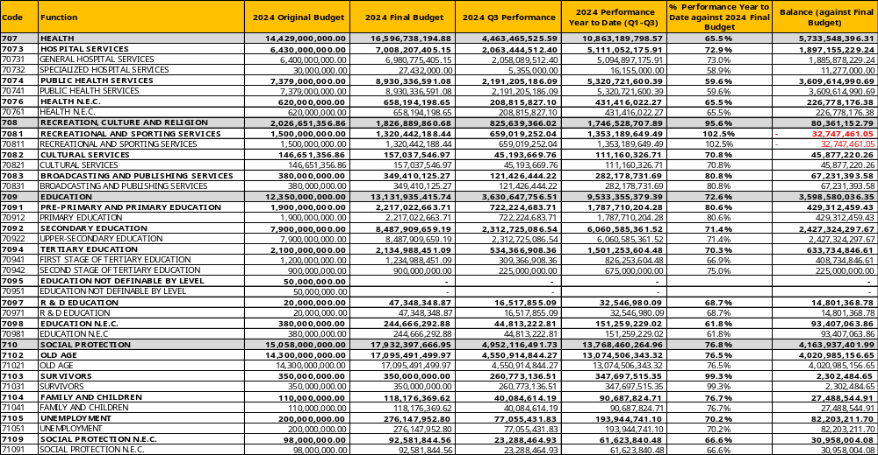
Table 12: Overhead Expenditure by Function
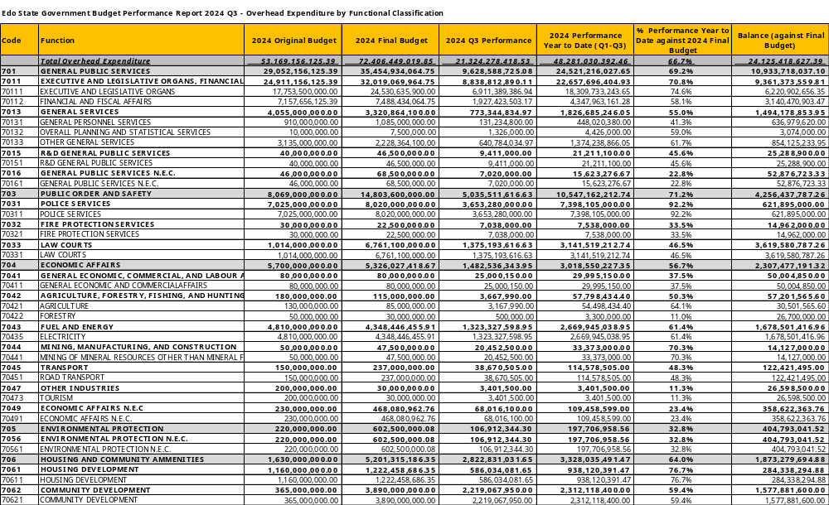
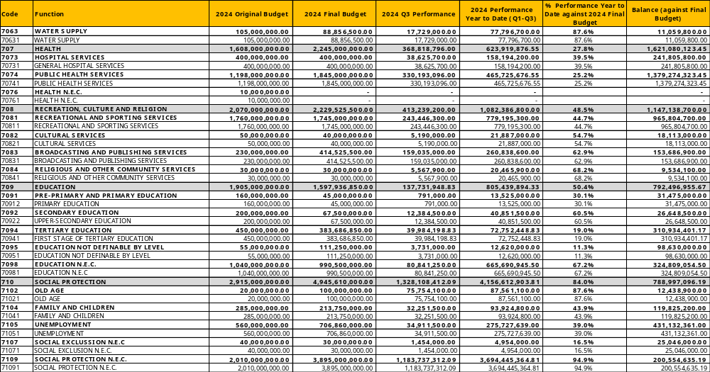
Table 13: Capital Expenditure by Function
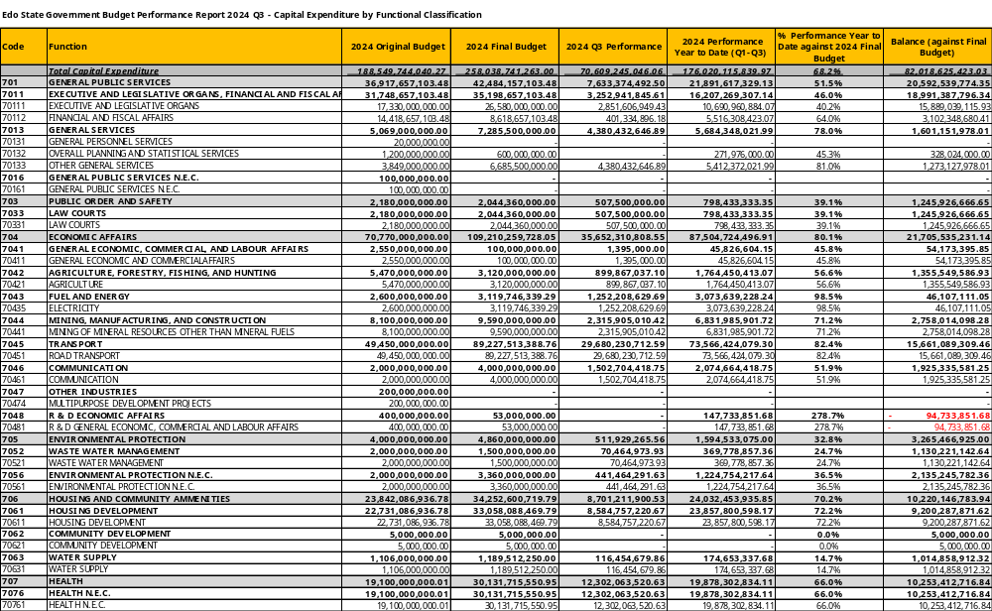
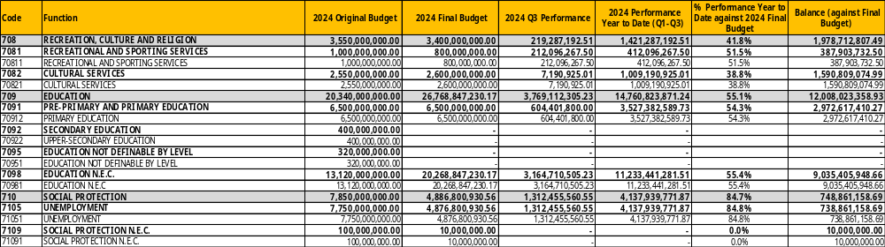

Table 14: Other Expenditure by Function
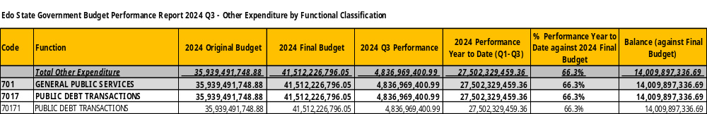

Table 15: Total Expenditure by Programme
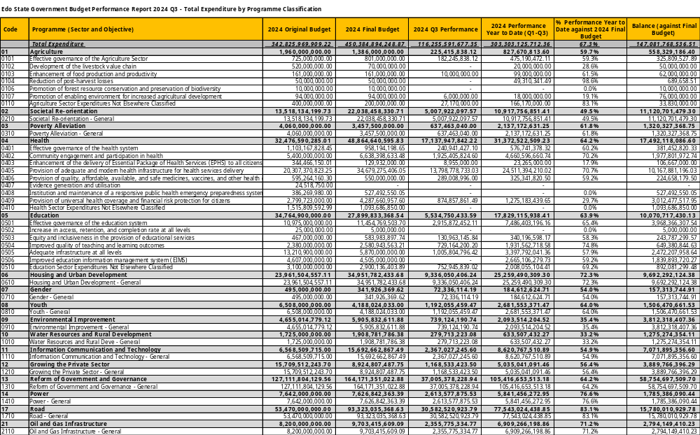
Table 16: Capital Expenditure by Programme
